**PRACTICAL NO: 4**

**AIM:** Configure DHCP server and client for DHCP service

**Steps to perform practical:**

Step 1 : Add router, switch and end user clients to the switches.

Step 2 : Connect all the devices with straight through cable.

Step 3 : Give IP to each port of router

enable

configure terminal

interface gig0/0/0

ip address 192.168.10.1 255.255.255.0

no shutdown

exit

Step 4 : Apply DHCP to the router

configure terminal

ip dhcp pool pool_name

network 192.168.10.0 255.255.255.0

default-router 192.168.10.1

exit

ip dhcp excluded-address 192.168.10.2 192.168.10.10 exit

Step 5 : Show DHCP ip address to each end user clients.

System > Desktop tab > ip configuration > select dhcp.

DHCP automatically assign ip address to each client.

**NETWORK TOPOLOGY:**



**i) Router Configuration:-**

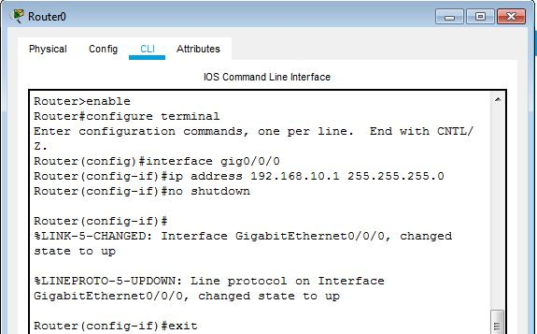**Set IP addresses to routers:-**

**ii)End User Client Configuration :**

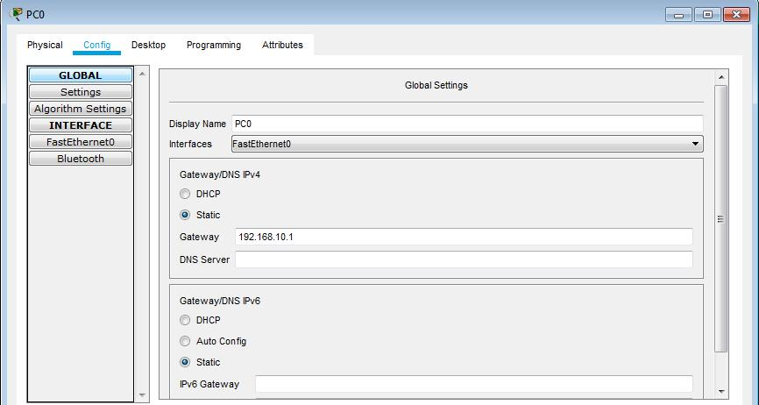**a)Set Gateway to end user client:**

Set Gateways to all remaining end user client.

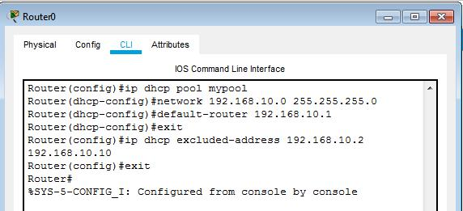**Set DHCP protocol to routers :**

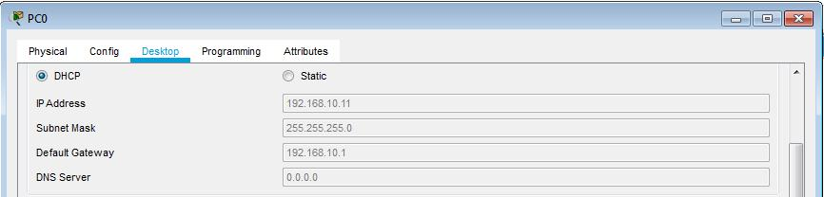**Show DHCP ip address to each end user clients.**

Show DHCP ip address to all remaining end user clients as shown above.

**FINAL TOPOLOGY:**

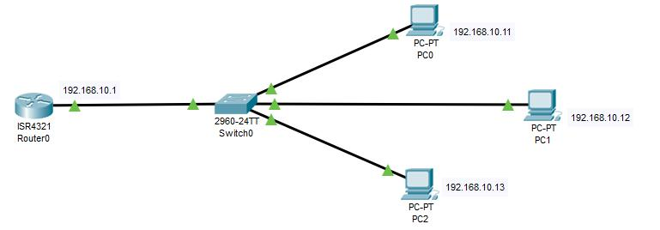

**Conclusion:-** We have learnt to create DHCP server with client service as shown above.